PRE-KINDY
ENROLMENT & INFORMATION SHEET - 2017
This pack will provide you will all the information you need to know about The Studio Kenthurst
OUR PHILOSOPHY
The Studio Kenthurst offers an exciting and unique approach in teaching the art of dance and performing arts. We strive to provide enjoyable, fun classes that are run in a competitive-free environment while maintaining a high standard of dance and technique. We take our roles very seriously as teachers and mentors in each of our student’s lives.
A big focus for our dancers is for them to feel good about themselves and their achievements. Our programs are designed to develop the “whole” child, not only by teaching them to dance but by building on their self-confidence with a positive mind and body image. Although classes are structured, they are conducted in a fun and relaxed atmosphere that allows children at all levels to enjoy dance and performing arts.

PRE- KINDY CLASSES FOR 2017 BEGIN ON THE WEEK COMMENCING MONDAY 6th FEBUARY 2017

QUICK REFERENCE GUIDE | PAGE NO.
HOW TO CONTACT US | 2
STUDIO LOCATION | 2
CONCERTS & SHOWS INFO | 2
UNIFORM & DRESS CODE | 3
FEES & PRICING | 4
2017 CALENDAR & DATES | 5
GENERAL INFORMATION | 6
CLASSES ON OFFER IN 2017 | 7
FREQUENTLY ASKED QUESTIONS (FAQ) | 8
TIMETABLE OF ALL CLASSES | 9
ENROLMENT FORM & FEE SCHEDULE | 10-11

CONTACT INFORMATION

Danielle Noll
Email: dance@thestudiokenthurst.com.au
Phone: 0499997636
Face Book: search ‘The Studio Kenthurst’
Website: www.thestudiokenthurst.com.au
Postal Address: PO BOX 299, Kenthurst, NSW, 2156

STAYING INFORMED
All newsletters and information will be emailed out. It is important that we have a current email address and for you to let us know if you are not receiving our information and updates.

Our other form of communication is on our Face Book Page. We post weekly information, news and photos. Please head to the link and like our page so you can keep informed on a weekly bases.
https://www.facebook.com/pages/The-Studio-Kenthurst/187400541309737

STUDIO LOCATION
131-135 Kenthurst Rd, Kenthurst, NSW 2156
Parking is at the rear of the building. Turn onto Nelson Street and follow it around until you see the driveway to the rear of the building.

MID YEAR SHOWCASE

We love seeing our students grow and improve and we are sure that you as parents do too. For this reason, we run a Mid- Year Showcase at the end of Term 2 and End of Year Concert at the end of Term 3.

Mid-Year Showcase - Sunday 2nd July, 2017
Our dancers learn a routine from the beginning of the year and perform for parents and friends. It also gives the parents an opportunity to see how their children are progressing after their first 4 months of dancing and gives the dancers their first opportunity for the year to get up on stage to perform. (Our Mid- Year Showcase requires our dancers to wear studio uniform only. No costumes are required until our end of year concert)

END OF YEAR CONCERT

End Of year Concert - Sunday 19th November, 2017
Our most anticipated event of the year…our dancers learn a great new routine in term 3 & 4 and wear amazing costumes…it is what our dancers work towards all year!

DANCE UNIFORM & DRESS CODE

The students tend to feel more comfortable when they look the same as their class mates. We feel it gives a sense of belonging and team atmosphere. For your convenience, we will have uniform and dance shoes available through the studio and the cost of the uniform is kept to a minimum so is affordable for everyone. It is preferred that all students wear the studio uniform.

- Appearance must be clean, neat and tidy. All long hair must be tied back neatly and in a tidy bun for ballet
- It is important that the correct shoes are purchased for each style. Dance shoes are to be worn during classes.
For your first couple of weeks, any singlet/top and shorts/tights are fine to get started if you are not sure about your child’s confidence to participate in the class. Sneakers are fine to wear until you are sure that your child will be continuing the class.
All students need to wear correct dance shoes and studio uniform in the mid-year showcase so it is a good idea to get them from the start of the year
CLASS | GIRLS | BOYS
JAZZ | Kenthurst Black Dance Singlet or leotard  Black Dance Shorts  Tan stockings in winter  Black ankle socks for summer  Black jazz shoes | Black Bonds Singlet  Black shorts (summer)  Black pants (winter)  Black ankle socks  Black jazz shoes
BALLET | Black leotard with skirt  Black Headband  Black X-over (winter)  Pink ballet stockings (winter)  Pink ballet socks (summer)  Pink leather ballet shoes | Black Bonds Singlet  Black shorts or fitted long pants  Black ballet shoes

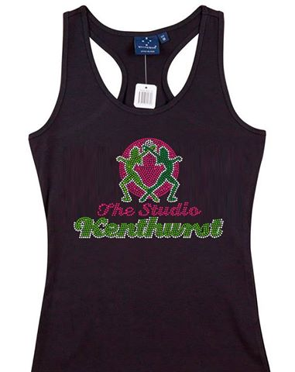

DANCE EDUCATION COSTS & PAYMENT DETAILS

At the beginning of each term you will be emailed an invoice with your dancer’s term costs. Please ensure that these are promptly paid by week 4 of each term.
DIRECT DEBIT DETAILS
BSB: 012246 ACC: 224482555 Account Name: The Studio Kenthurst

- Classes must be paid for whether your child attends their lesson or not.
- If your child misses a class they are more than welcome to attend a similar class (within the same term) to make up for their missed lesson. If you go on holidays, classes still must be paid for in full to ensure your child’s place in the class is held.

LESSON FEES 2017
30min classes | $12.00

Family Friendly Fee Capping
The Studio Kenthurst offers a fee capping system to make it more affordable for our families.
Pre-Kindy/Tiny Tots: Your fees are capped at $50/week

Family Discounts
Another way we like to try and make classes affordable for families is to offer the 3rd and subsequent children in one family to dance for free (this is the least paying student from the family). So for any family at the Studio you only ever pay class fees for your first two children. The rest of the children have their class fees waived.

Costume Deposit Fund
At The Studio Kenthurst we run a costume deposit fund. This is to help ease the financial burden at the end of the year. We try to keep costume costs to a minimum and know that our parents appreciate that. This cost includes: measuring your child, materials, dress making, shipping, accessories, hair accessories, props and costume bag. (AND….. you get to keep your costume!)

Pre-Kindy/Tiny Tots classes: will consist of $20 installments per child, per class, per term (3 terms - total $60/costume)
If you leave or decide not to perform in the concert (before the costumes are ordered), the deposited amount can be refunded

THE STUDIO KENTHURST 2017 CALENDAR
JANUARY | FEBRUARY | MARCH
SUN 22nd - REGO & DISCOUNT UNIFORM DAY (11am-1pm)  MON 30th - START TERM 1 | MON 13TH – TERM 1 FEES DUE  MON 13TH – TERM 1 COSTUME DEPOSITS DUE
APRIL | MAY | JUNE
SAT 8TH – END TERM 1  FRI 14TH – GOOD FRIDAY  SAT 15TH – EASTER SATURDAY  MON 16TH – EASTER MONDAY  MON 24TH – START TERM 2  TUE 25TH – ANZAC DAY | SUN 7th– Kenthurst Country Fair  PJ Week – TBA*  MON 8TH – TERM 2 FEES DUE  MON 8TH – TERM 2 COSTUME DEPOSITS DUE | MON 12TH – QUEENS BIRTHDAY  MON 5TH - TICKETS ON SALE FOR MID YEAR CONCERT  WK STARTING SAT 24TH – MEASUREMENT AND COSTUME FORMS DUE  25TH – MID YEAR DRESS REHEASHAL  SAT 1ST – END TERM 2
JULY | AUGUST | SEPTEMBER
SUN 2nd – MID YEAR SHOWCSE  MON 17TH – START TERM 3  MON 31ST – TERM 3 FEES DUE  MON 31ST – TERM 3 COSTUME DEPOSITS DUE | SUN 6th – KENTHURST KINDY FETE | SUN 10th – KENTHURST ORANGE BLOSSOM FESITVAL & STREET PARADE  SAT 23RD – END TERM 3
OCTOBER | NOVEMBER | DECEMBER
MON 9TH – START TERM 4  MON 23RD – TICKETS ON SALE FOR END YEAR CONCERT  MON 23RD – TERM 4 FEES DUE | SAT 4TH – PHOTO DAY  SUN 26th – END OF YEAR DRESS REHERSHAL | SAT 2nd – END TERM 4  SUN 3rd – END YEAR CONCERT  MON 4TH – END OF YEAR PARTY

GENERAL INFORMATION

CLASS ATTENDANCE
If you miss three classes in a row without contacting us, we will assume you have discontinued. If you need to miss three classes due to things like a holiday or ill health, please let us know and we will be happy to hold your place in the class. You can email, call or SMS Miss Danielle 0499997636 if your child is unable to attend their class.
PHOTOGRAPHY & PROMOTIONS
Through-out the year, your child may be photographed or filmed for promotional or advertising purposes. This may include but not limited to photos on our FACEBOOK page, local newspaper articles or published on The Studio Kenthurst website. If you do not want your child’s photograph to be used, please advise staff in writing when you enroll.

IMPORTANT SAFETY RULES
Once you have enrolled, all students and their families are expected to adhere to a few simple rules for the safety and well being of everyone involved in the studio.
- No food containing nuts or nut product can be brought into the studio by a parent, student or sibling.
- Children must not enter the dance studio area unless accompanied by a teacher
- Children must not leave the building unless accompanied by a parent or guardian
- Before and after class, students are expected to be supervised by their parents. Teacher supervision extends only to students in class.

CAR PARK SAFETY & PARKING

We have children of all ages attending our studio. Please enter and exit our car parks with extreme caution.

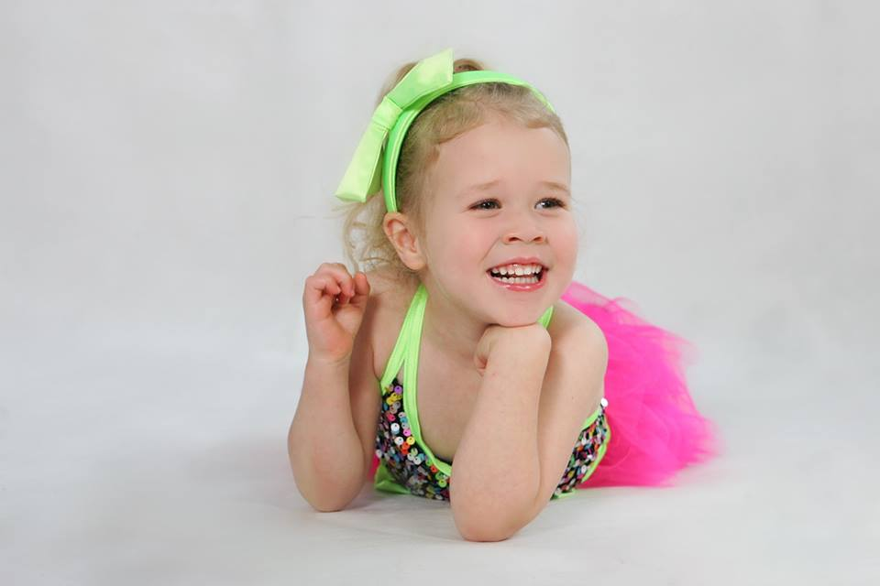

PRE-KINDY CLASSES FOR 2017

Students are not placed in classes based primarily on their age, but experience, ability and friends are important factors that can determine what class is best suited for them. Develop confidence and new skills while making lifelong friendships through our Pre-Kindy dance classes. With the encouragement of creative thinking and the exploration of dance, your little dancer can experience fun & excitement!

“All classes have been specifically programmed to allow our dancers to continually improve on technique, co-ordination and choreography while always ensuring creativity and fun! All teachers have been trained with this syllabus to ensure all our dancers are developing and learning at a consistent pace.”

PRE-KINDY
- Dance Movement: It is the essential tool for the basics of dance. Involving more then one style for both boys and girls focusing on the fundamentals of movement and dance.

- Ballet: It is the essential tool for the basics of dance. Ballet promotes body placement, posture awareness and emotion while preparing the dancer for all styles of dance. Although children do not sit for exams, classes are directed by set syllabi.

Our Pre-Kindy classes are 30 minutes offered to little ones not yet at school. We are offering Monday, Wednesday & Saturday mornings.

Our program includes the elements of dance, drama, games and props. The program involves lots of fun and laughter. Through out the program we focus on developing the child’s dance technique through the elements of strength, flexibility & co-ordination. When a child gets involved in dancing & singing it stimulates the whole brain and releases endorphins resulting in a happy mood. Other activities included in our programs are: speech and language development, improvisation and creative movement.

Don’t worry if you think your little one is shy or may not join in, we have lots of experience in working and encouraging little ones and ensuring they feel comfortable in their environment. Eventually to stage were they will stand by the door say goodbye and join in the fun.

Monday Morning | Studio 1
9:30 – 10:00 am | Dance Movement ages 2-4
10:00 – 10:30am | Ballet ages 2-4

FREQUENTLY ASKED QUESTIONS
Can mum & dad watch the class? First time parents of the younger groups may watch the beginning of the first class to help settle dancers in. After this we find that the children respond much better without parents and siblings in the studio. However, after many years of experience, special tactics are used for those who have trouble separating from their parents, so don’t worry if it takes your dancer a couple of weeks to feel comfortable and participate.
For all other classes, parents are not permitted to enter or be present in the studio once class has commenced. It is distracting and unsettling for all the dancers. We will give the parents a chance to have a sneak peak of the class for the last 10mins of class during the final week of the term 1 and 3.
Is it compulsory to participate in the mid-year & end of year concert? Our concerts are not compulsory but highly recommended. It’s a fun and entertaining experience for everyone involved and a great way for your dancer to show off all their hard work they have done throughout the year. Our concerts are designed to be pressure free and as relaxed as possible for everyone involved.
Our mid-year concert is usually held the week before the June/July School Holiday and our end of year concert is usually the 3rd or 4th Sunday in November, so the dancing year finishes before the massive rush and commitments of Christmas start.
Can I enroll after the dancing year has started? Yes - we accept new students throughout the year. Just email us at: dance@thestudiokenthurst.com.au for an information sheet and timetable.
Does The Studio Kenthurst break for School & Public Holidays? Yes - we dance within the NSW Schools Terms, therefore following NSW School holidays and Public Holidays (except our starting week of the year and our finishing week of the year). Also, our first week back of term will always starts on a Monday (unless it’s a Public Holiday) even if your child’s school has a pupil free day.
Do I need to buy a dance uniform or shoes before I enroll? No - dancers trying classes for the first time are encouraged to come in comfy clothes and sneakers. Uniform can be purchased at the studio once your dancer is sure they want to commit.

REGISTRATION & ENROLMENT FORM

MOTHER and/or FATHER’S NAME

ADDRESS

EMAIL ADDRESS

TELEPHONE NUMBERS
CLASS | Student 1 | Student 2 | Student 3 | Student 4

Dance Movement (please stipulate which day)

Ballet (please stipulate which day)

STUDENT’S NAMES & DOB | 1. | DOB 1.
 | 2. | DOB 2.
 | 3. | DOB 3.
 | 4. | DOB 4.

TERMS & CONDITIONS
The Studio Kenthurst
- Does your child have any medical conditions of which we should be aware? No / Yes (please circle)
(If yes, please specify)
...............................................................................................................................................................

- How did you hear about us? (please circle) Internet – Friend - Newspaper - Social Media - Other (please specify) ……………………..…………………………………………………………………………………………………………………………

- If you were referred by someone already at the studio, could you please leave their details below as we would like to thank them.

Name:……………………..……………………………………….......................................................................................................

- Parents are responsible for their child’s behaviour and their safety whilst on our premises, including parking lots, bathrooms, waiting areas etc.

- I understand that children are not allowed in the studio when not participating in the class that is in progress but they can
wait in the waiting area inside the building.

I will exercise extreme caution when entering and exiting the car parks. It is my responsibility to ensure that my child safely

enters the studio and return to my vehicle at the end of class. I will not park my vehicle in any area that is not a designated parking space.

- Fees and full costume payments will be required to be finalised in order for your child to participate in our end of year
concert.

- I understand that through-out the year, my child may be photographed or filmed for promotional or advertising purposes.
This may include but not limited to photos on our social media pages, local newspapers or published on websites. I have no objection to my child’s photograph or video footage of my child to be used by The Studio Kenthurst and Danielle Noll for such purposes.

- Please be advised that all classes are well supervised and each dancer participates at their own risk therefore no responsibility will be placed upon the teacher or studio should your child sustain any injuries during the course of any class. Safety rules have been stipulated in this information letter and have been formulated for everyone’s safety.

Signature…………………………………………..…………………..….. (parent/guardian)

Date……..……..………….……………..

Danielle Noll
The Studio Kenthurst
Po Box: 299, Kenthurst, NSW, 2156
Email: dance@thestudiokenthurst.com.au
Phone: 0499997636
Facebook: ‘Search’ The Studio Kenthurst and for updates

